It looks like someone else project and it does not reflect my requests

where's this

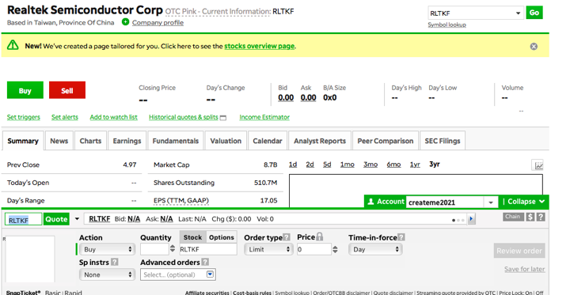

these design is on TD Ameritrade [https://youtu.be/WNCOGF7dDng](https://www.freelancer.com/users/l.php?url=https:%2F%2Fyoutu.be%2FWNCOGF7dDng&sig=34a885fb3852fdbc5b6d7bc552a02c3b69251e7c5e9b9a24c33e53068897618c)

This shows simplicity reveres and forward and depth [https://youtu.be/WNCOGF7dDng](https://www.freelancer.com/users/l.php?url=https:%2F%2Fyoutu.be%2FWNCOGF7dDng&sig=34a885fb3852fdbc5b6d7bc552a02c3b69251e7c5e9b9a24c33e53068897618c)

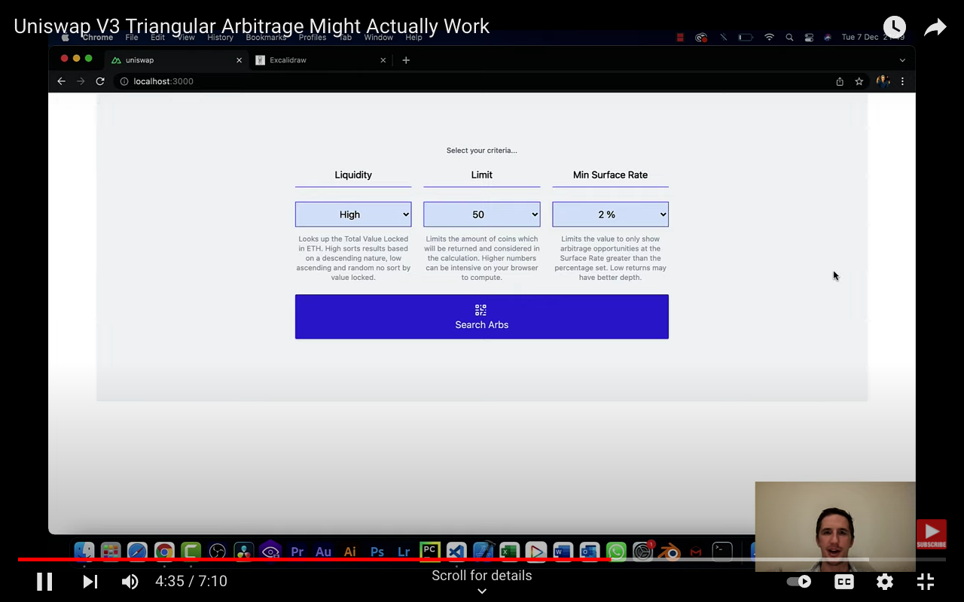

also fix and market rate



he also talks about updated features

There should be fix and market rate settings arbitrage for stock and crypto currency as well. That shows the name of different stock exchanges

also the background pallet is white and virtually digital like on domo

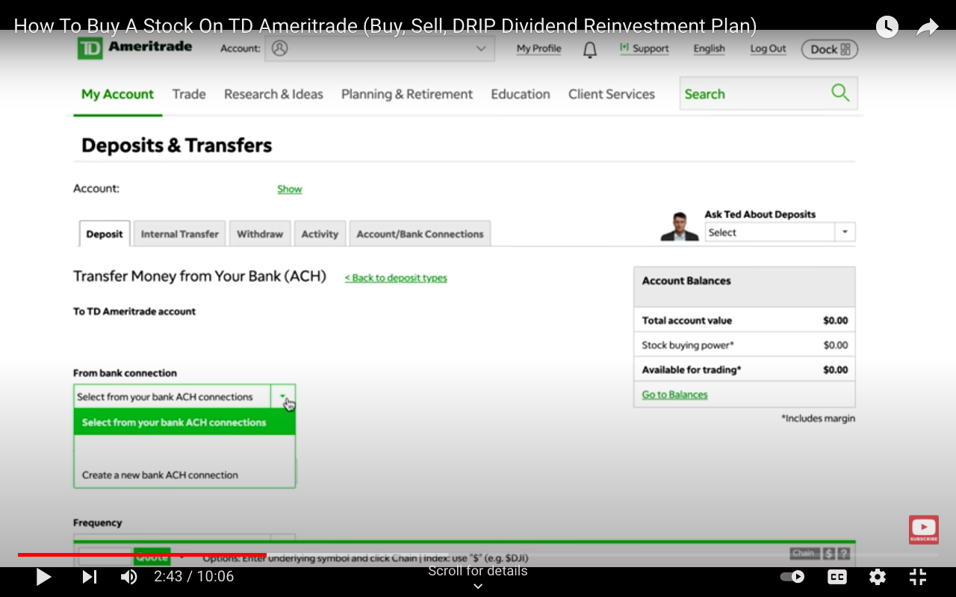

for transfer of funds

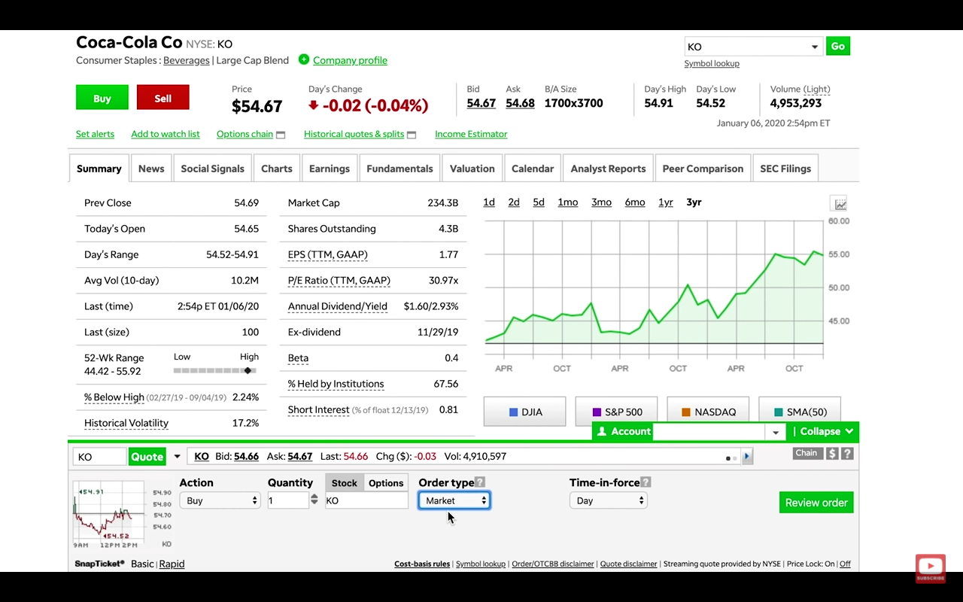

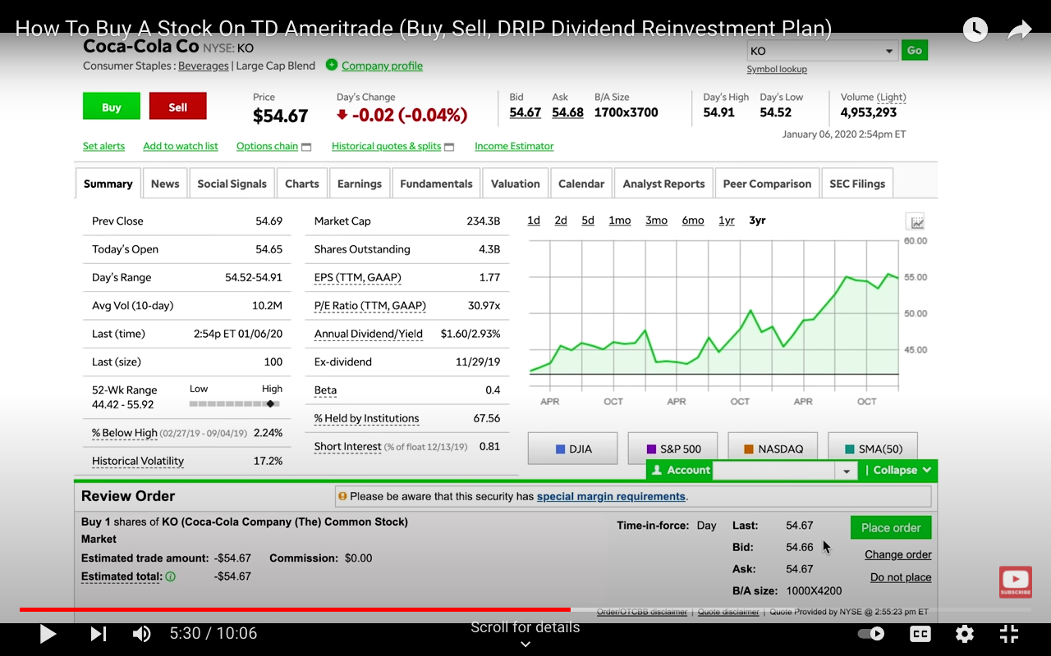

you can buy and review the order before purchase if you look at the bottom and it does all the calculations for you with types of orders

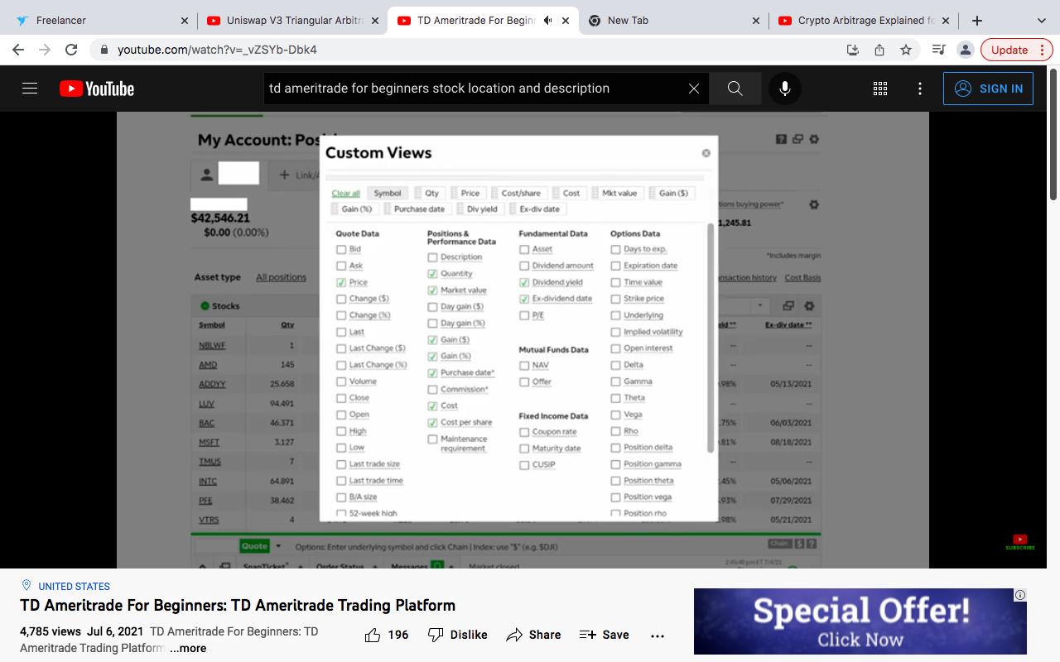

Custom features

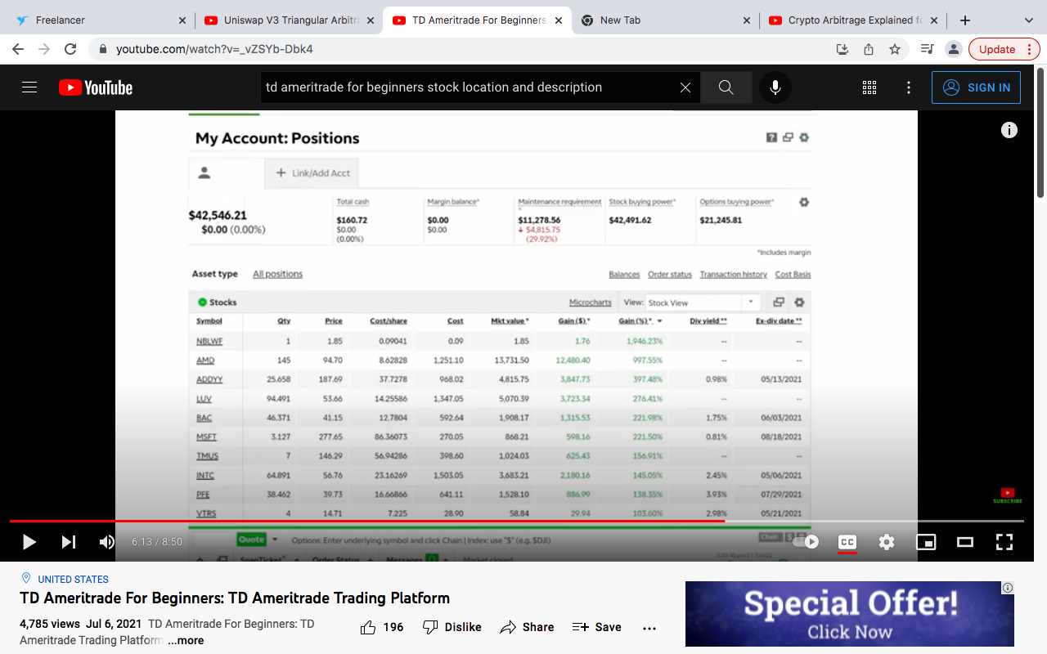

[https://youtu.be/jW_sZArHQmE](https://www.freelancer.com/users/l.php?url=https:%2F%2Fyoutu.be%2FjW_sZArHQmE&sig=03491f2ad1ee1fc217ee926b319b19365e2835d6ee14f8254e6cce850b89cb2f)

[https://youtu.be/CMv2jwRzzGQ](https://www.freelancer.com/users/l.php?url=https:%2F%2Fyoutu.be%2FCMv2jwRzzGQ&sig=ac680f3c207b34678afb18053f7312b637c6081ea32317be333fbc771af6f401)

[https://youtu.be/70zKa36agGU](https://www.freelancer.com/users/l.php?url=https:%2F%2Fyoutu.be%2F70zKa36agGU&sig=2d9608f9a5dadcd8b909c94ae745905d424583076086e4883aa1909b0c7b535f)

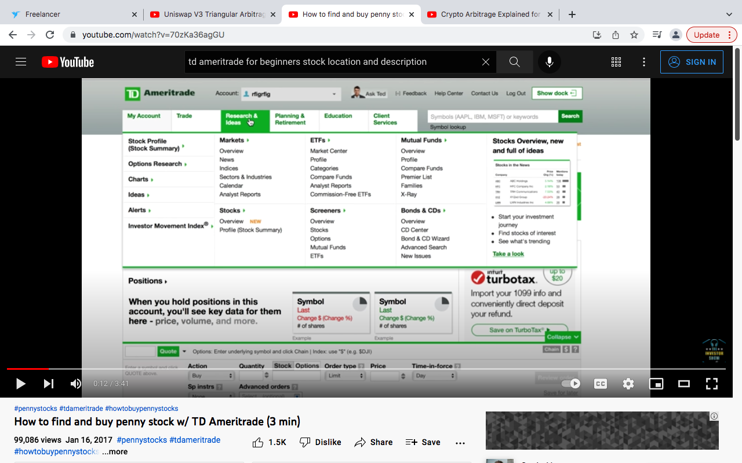

alot of the features are here but there no quires by stock locations meaning name, ticker symbol city and country

here's instant article wizard it has the best design and features [https://youtu.be/Idy3twSPd8I](https://www.freelancer.com/users/l.php?url=https:%2F%2Fyoutu.be%2FIdy3twSPd8I&sig=512c8d65518fee540d5ec094c7fe356d4c1ec0dad51b93bb097401dacaedfb12)

just trying to give samples of designs and features for help

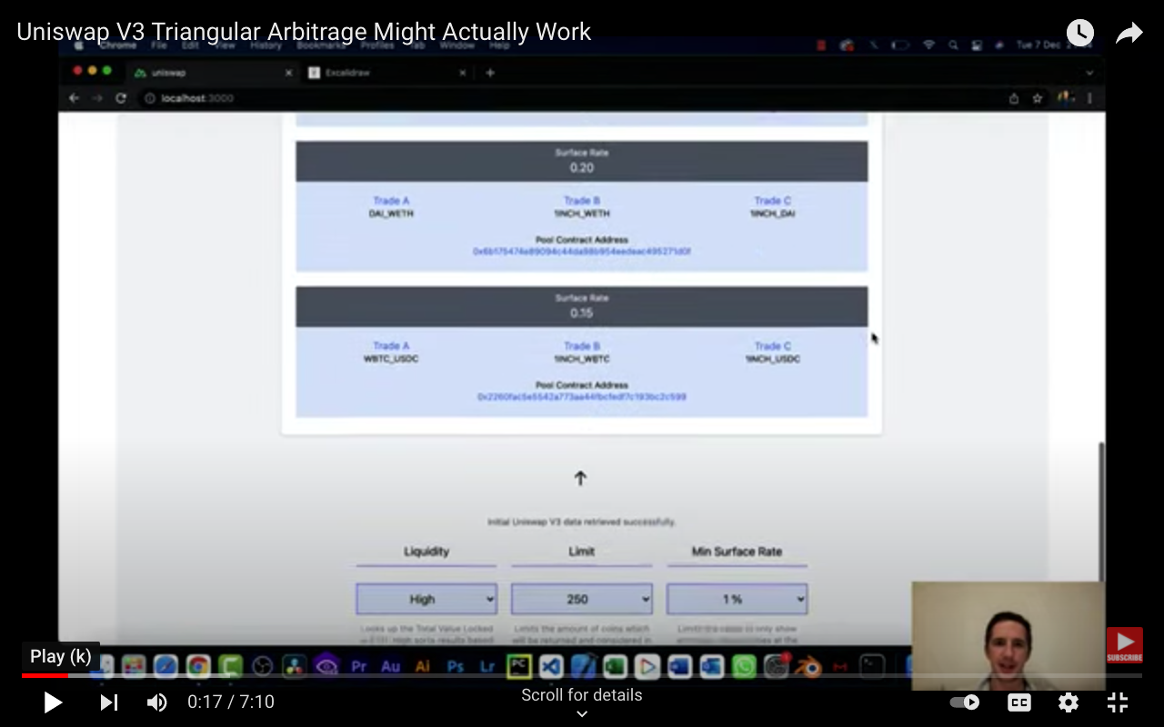

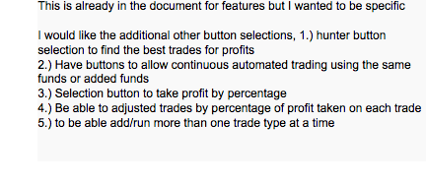

[https://youtu.be/YLB8fc0i_xY](https://www.freelancer.com/users/l.php?url=https:%2F%2Fyoutu.be%2FYLB8fc0i_xY&sig=8bd626e6a746e2851cad09985f43746534fe3389d3b170f0801add22164d6066) This is already in the document for features but I wanted to be specific I would like the additional other button selections, 1.) hunter button selection to find the best trades for profits 2.) Have buttons to allow continuous automated trading using the same funds or added funds 3.) Selection button to take profit by percentage 4.) Be able to adjusted trades by percentage of profit taken on each trade 5.) to be able add/run more than one trade type at a time